Putting it together Inference
Charley Kirk
11/18/2024

Setup
First load the necessary packages
library(ggplot2)
library(dplyr)
library(moderndive)
library(readr)
library(infer)
Adapted from by Cannon, Cobb, Hartlaub, Legler, Lock, Moore, Rossman and Witmer and JSE Bradley, S., (2015), “Handwriting and Gender: A Multi-use Dataset”, JSE (Datasets and Stories). March 2015.

Background
A survey was done with a sample of 204 Clarke University students. Each student was given 25 handwriting specimens and they were to guess, as best as they could, the gender (male or female) of the person who penned the specimen. (Each specimen was a handwritten address, as might appear on the envelope of a letter. There were no semantic clues in the specimen that could tip off the author’s gender.) The survey was repeated two times – the second time was the same 25 specimens given in a randomly assigned new order.
One might hope that subjects would be consistent in their guesses between the two surveys. To investigate the salience of this hope, we look at the relationship between the variables Survey1 and Survey2 which give, respectively, the percentage of successes for the two surveys.
Here’s a list and description of the variables:
- Individual - Survey Respondent Number
- Gender - Gender of Respondent (0 = male, 1 = female)
- Survey1 - Percent correct on Survey 1
- Survey2 - Percent correct on Survey 2
- FemaleID - Percent correct in identifying female specimens on Survey 1
- MaleID - Percent correct in identifying male specimens on Survey 1
- Both - Percent correctly identified on Survey 1 AND Survey 2
- DIFF - Survey1 - Survey2 percentages correct
Handwriting <- read_csv("~/Dropbox/Charley/Juniata/Data Science Masters/Statistics Fundamentals/Handwriting.csv")
## New names:
## Rows: 204 Columns: 9
## ── Column specification
## ──────────────────────────────────────────────────────── Delimiter: "," dbl
## (9): ...1, Individual, Gender, Survey1, Survey2, FemaleID, MaleID, Both,...
## ℹ Use `spec()` to retrieve the full column specification for this data. ℹ
## Specify the column types or set `show_col_types = FALSE` to quiet this message.
## • `` -> `...1`
as.factor(Handwriting$Gender)->Handwriting$Gender #sets as a categorical variable
glimpse(Handwriting)
## Rows: 204
## Columns: 9
## $ ...1 <dbl> 1, 2, 3, 4, 5, 6, 7, 8, 9, 10, 11, 12, 13, 14, 15, 16, 17, …
## $ Individual <dbl> 1, 2, 3, 4, 5, 6, 7, 8, 9, 10, 11, 12, 13, 14, 15, 16, 17, …
## $ Gender <fct> 1, 0, 1, 1, 1, 1, 0, 0, 0, 1, 0, 1, 0, 0, 1, 0, 0, 1, 0, 1,…
## $ Survey1 <dbl> 72, 56, 68, 80, 76, 76, 60, 68, 52, 64, 64, 64, 64, 68, 60,…
## $ Survey2 <dbl> 68, 68, 48, 80, 72, 60, 60, 68, 48, 72, 72, 72, 56, 76, 72,…
## $ FemaleID <dbl> 75.0, 41.7, 75.0, 83.3, 83.3, 75.0, 66.7, 75.0, 33.3, 75.0,…
## $ MaleID <dbl> 69.2, 69.2, 61.5, 76.9, 69.2, 76.9, 53.8, 61.5, 69.2, 53.8,…
## $ Both <dbl> 68, 48, 36, 76, 68, 60, 36, 64, 36, 64, 44, 64, 44, 60, 60,…
## $ DIFF <dbl> 4, -12, 20, 0, 4, 16, 0, 0, 4, -8, -8, -8, 8, -8, -12, -16,…

Is there a difference between the percentage correct a woman guesses on survey 1 and the percentage a man guesses on survey 1?

Question 1
a) State the null and alternate hypotheses to test this statement.
$$\begin{matrix}H_{0}: & μ_{male}=μ_{female} \\ \text{vs}H_{A}: & μ_{male}≠μ_{female}\end{matrix}$$
Where $μ_{female}$ is the mean percentage correct a woman guesses on survey 1 and $μ_{male}$ is the mean percentage correct a man guesses on survey 1.
b) Test your hypothesis using a t-test. Be sure to check the required conditions for the theoretical test.
ggplot(data=Handwriting, mapping=aes(x=Survey1))+geom_histogram(bins = 30)+facet_wrap(~Gender)
## Warning: Removed 4 rows containing non-finite outside the scale range
## (`stat_bin()`).
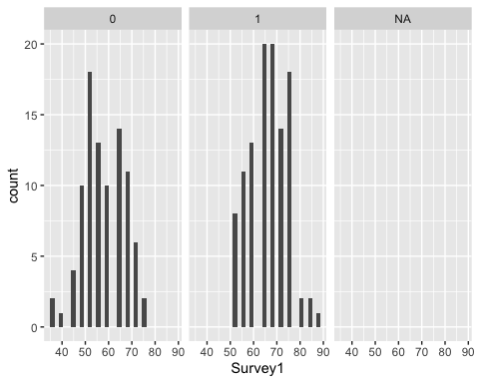
The histogram for males seems relatively bell-shaped, but for the female histogram it’s harder to say.
Handwriting %>% group_by(Gender) %>% summarise("standard deviation"=sd(Survey1, na.rm=TRUE))
## # A tibble: 3 × 2
## Gender `standard deviation`
## <fct> <dbl>
## 1 0 8.97
## 2 1 8.11
## 3 <NA> NA
The larger standard deviation is not more than twice as large as the smaller standard deviation.
t.test(Survey1 ~ Gender, var.equal = TRUE, data = Handwriting)
##
## Two Sample t-test
##
## data: Survey1 by Gender
## t = -7.163, df = 198, p-value = 1.517e-11
## alternative hypothesis: true difference in means between group 0 and group 1 is not equal to 0
## 95 percent confidence interval:
## -11.039696 -6.273339
## sample estimates:
## mean in group 0 mean in group 1
## 57.80220 66.45872
We obtained a p-value of 1.517e-11, so we reject the null hypothesis at the 5% significance level and we conclude that there is a difference between the mean percentage correct a woman guesses on survey 1 and the mean percentage correct a man guesses on survey 1

Simple Regression

Question 2
Make and describe a scatterplot of the data with Survey1 on the x-axis and Survey2 on the y-axis.
Handwriting%>%
ggplot()+
geom_point(aes(Survey1, Survey2))
## Warning: Removed 9 rows containing missing values or values outside the scale range
## (`geom_point()`).
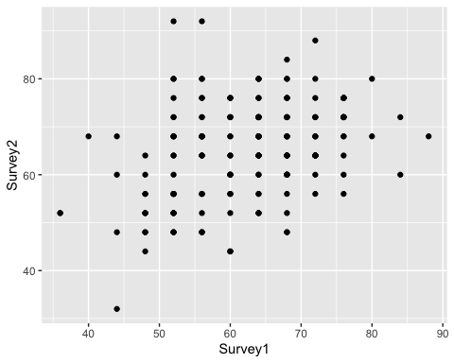
The scatterplot suggest a weak positive correlation between Survey 1 and Survey2.

Question 2a. What does each dot on the scatterplot represent?
Each dot on the scatterplot represents a separate observation in the dataset, in particular the combination of the value in Survey1 and the value in Survey2 for that observation.

Question 3
Create a regression for the above relationship and write down the regression equation.
survey_model <- lm(Survey2 ~ Survey1, data = Handwriting)
get_regression_table(survey_model)
## # A tibble: 2 × 7
## term estimate std_error statistic p_value lower_ci upper_ci
## <chr> <dbl> <dbl> <dbl> <dbl> <dbl> <dbl>
## 1 intercept 40.4 4.43 9.12 0 31.7 49.2
## 2 Survey1 0.395 0.07 5.64 0 0.257 0.533
Predicted Survey2 = Survey1 * 0.395 + 40.417.

Question 4
If gender could be predicted well by handwriting, we would expect that percent guessed correct on Survey1 would equal the percent guessed correct on Survey2. How well does this model fit the situation described by the data?
a) Is this model appropriate to use?
First check LINE
Handwriting%>%
ggplot(aes(Survey1, Survey2))+
geom_point()+
geom_smooth(method = "lm", se = FALSE)
## `geom_smooth()` using formula = 'y ~ x'
## Warning: Removed 9 rows containing non-finite outside the scale range
## (`stat_smooth()`).
## Warning: Removed 9 rows containing missing values or values outside the scale range
## (`geom_point()`).
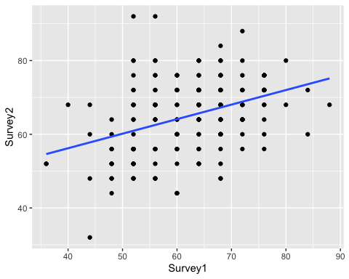
I would say that this relationship is linear enough.
Regarding independence, each individual observation in the dataset corresponds to one unique student out of the 204 Clarke University students.
Handwriting
## # A tibble: 204 × 9
## ...1 Individual Gender Survey1 Survey2 FemaleID MaleID Both DIFF
## <dbl> <dbl> <fct> <dbl> <dbl> <dbl> <dbl> <dbl> <dbl>
## 1 1 1 1 72 68 75 69.2 68 4
## 2 2 2 0 56 68 41.7 69.2 48 -12
## 3 3 3 1 68 48 75 61.5 36 20
## 4 4 4 1 80 80 83.3 76.9 76 0
## 5 5 5 1 76 72 83.3 69.2 68 4
## 6 6 6 1 76 60 75 76.9 60 16
## 7 7 7 0 60 60 66.7 53.8 36 0
## 8 8 8 0 68 68 75 61.5 64 0
## 9 9 9 0 52 48 33.3 69.2 36 4
## 10 10 10 1 64 72 75 53.8 64 -8
## # ℹ 194 more rows
get_regression_points(survey_model)%>%
ggplot(aes(x = residual)) +
geom_histogram(color = "white")
## `stat_bin()` using `bins = 30`. Pick better value with `binwidth`.
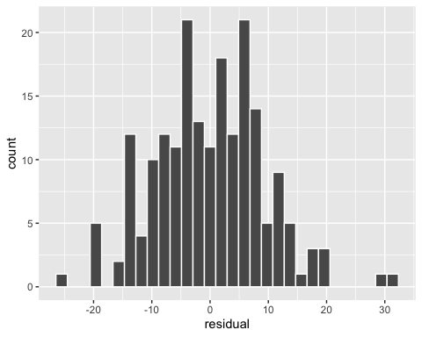
The histogram of the residuals is relatively bell-shaped and appears to be centered on 0.
get_regression_points(survey_model)%>%
ggplot(aes(x = Survey1, y = residual)) +
geom_point() +
geom_hline(yintercept = 0, col = "blue", size = 1)
## Warning: Using `size` aesthetic for lines was deprecated in ggplot2 3.4.0.
## ℹ Please use `linewidth` instead.
## This warning is displayed once every 8 hours.
## Call `lifecycle::last_lifecycle_warnings()` to see where this warning was
## generated.
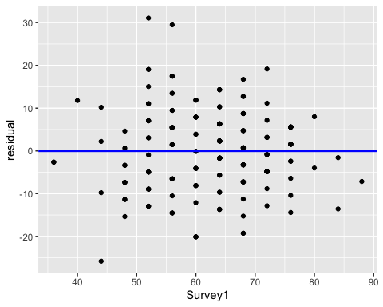 The spread of the residuals around the line at y=0 appears constant across all values of the explanatory variable Survey1.
Altogether I would say survey_model meets the conditions of LINE.
b) Comment on the p-value for the slope.
get_regression_table(survey_model)
## # A tibble: 2 × 7
## term estimate std_error statistic p_value lower_ci upper_ci
## <chr> <dbl> <dbl> <dbl> <dbl> <dbl> <dbl>
## 1 intercept 40.4 4.43 9.12 0 31.7 49.2
## 2 Survey1 0.395 0.07 5.64 0 0.257 0.533
summary(survey_model)
##
## Call:
## lm(formula = Survey2 ~ Survey1, data = Handwriting)
##
## Residuals:
## Min 1Q Median 3Q Max
## -25.7870 -6.4722 0.6339 5.9487 31.0547
##
## Coefficients:
## Estimate Std. Error t value Pr(>|t|)
## (Intercept) 40.41661 4.43100 9.121 < 2e-16 ***
## Survey1 0.39478 0.07004 5.637 6.07e-08 ***
## ---
## Signif. codes: 0 '***' 0.001 '**' 0.01 '*' 0.05 '.' 0.1 ' ' 1
##
## Residual standard error: 9.338 on 193 degrees of freedom
## (9 observations deleted due to missingness)
## Multiple R-squared: 0.1414, Adjusted R-squared: 0.1369
## F-statistic: 31.77 on 1 and 193 DF, p-value: 6.074e-08
The p-value for the slope is pretty low at 6.074e-08, according to the summary function.
c) Comment on the usefulness of the model. Does the percent guessed correct on Survey1 would equal the percent guessed correct on Survey2? Be sure to think through what this means in the context of the data! What would we expect the slope to be if there was no learning going on? Does learning occur?
Handwriting%>%
summarise(mean(Survey1, na.rm = TRUE), mean(Survey2, na.rm = TRUE))
## # A tibble: 1 × 2
## `mean(Survey1, na.rm = TRUE)` `mean(Survey2, na.rm = TRUE)`
## <dbl> <dbl>
## 1 62.5 65.0
If on average a student got the same percentage of correct answers on Survey 2 as they did on Survey 1, we would expect the slope estimate to be at or near 1. We would probably expect a slope estimate at 1, near 1, or even below 1 if there was no learning going on. The slope estimate is 0.395 and the confidence interval for the slope given by lower_ci and upper_ci in the regression table output does not contain 1 or any negative numbers. The fact that the slope estimate is below 1 could suggest that the ordering of specimens had an effect on correct answers or that students formed incorrect assumptions based on their first review of the specimens in Survey 1. I would say there’s no learning going on, but without a hypothesis test I can’t reach a conclusion on whether or not the population mean for Survey1 is equal to the population mean for Survey2.

We add Gender to see if the relationship depends on Gender of the respondent (Gender was recorded in binary terms).

Question 5
Create the scatterplot, coloring the points by the variable Gender. Add separate regression lines.
Handwriting%>%
ggplot(aes(Survey1, Survey2, color=Gender))+
geom_point()+
geom_smooth(method = "lm", se=FALSE)
## `geom_smooth()` using formula = 'y ~ x'
## Warning: Removed 9 rows containing non-finite outside the scale range
## (`stat_smooth()`).
## Warning: Removed 9 rows containing missing values or values outside the scale range
## (`geom_point()`).
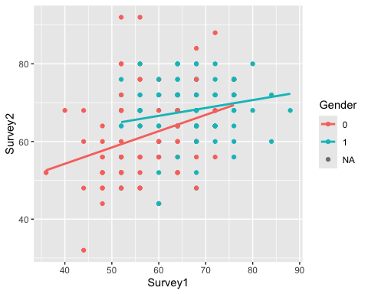

Question 6
Comment on the differences between men and women respondents that you observe.
The slope of the line for male respondents is greater than the slope of the line for female respondents, which could suggest that male respondents learn more from Survey1 than female respondents.

Question 7
a) Create a regression model that includes Gender as an indicator variable. Do not include an interaction term until question 8.
surveygender <- lm(Survey2 ~ Survey1 + Gender, data = Handwriting)
get_regression_table(surveygender)
## # A tibble: 3 × 7
## term estimate std_error statistic p_value lower_ci upper_ci
## <chr> <dbl> <dbl> <dbl> <dbl> <dbl> <dbl>
## 1 intercept 43.6 4.59 9.50 0 34.6 52.7
## 2 Survey1 0.313 0.078 4.04 0 0.16 0.466
## 3 Gender: 1 3.46 1.49 2.33 0.021 0.529 6.40
get_regression_points(surveygender)
## # A tibble: 195 × 6
## ID Survey2 Survey1 Gender Survey2_hat residual
## <int> <dbl> <dbl> <fct> <dbl> <dbl>
## 1 1 68 72 1 69.7 -1.65
## 2 2 68 56 0 61.2 6.82
## 3 3 48 68 1 68.4 -20.4
## 4 4 80 80 1 72.2 7.84
## 5 5 72 76 1 70.9 1.10
## 6 6 60 76 1 70.9 -10.9
## 7 7 60 60 0 62.4 -2.43
## 8 8 68 68 0 64.9 3.06
## 9 9 48 52 0 59.9 -11.9
## 10 10 72 64 1 67.1 4.86
## # ℹ 185 more rows
b) Determine if it is a useful model by commenting on LINE and p-value for the coefficients.
Handwriting%>%
ggplot(aes(Survey1, Survey2, color=Gender))+
geom_point()+
geom_parallel_slopes(se=FALSE)
## Warning: Removed 9 rows containing non-finite outside the scale range
## (`stat_parallel_slopes()`).
## Warning: Removed 9 rows containing missing values or values outside the scale range
## (`geom_point()`).
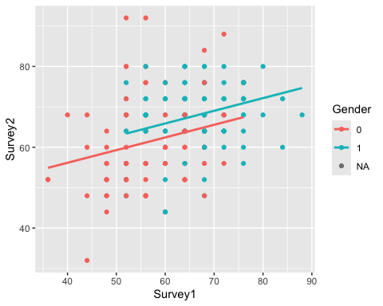 The relationship does not appear to be obviously nonlinear.
Regarding independence, again we know that each individual observation in the dataset corresponds to one unique student out of the 204 Clarke University students.
get_regression_points(surveygender)%>%
ggplot(aes(residual))+
geom_histogram()+
facet_wrap(~Gender)
## `stat_bin()` using `bins = 30`. Pick better value with `binwidth`.
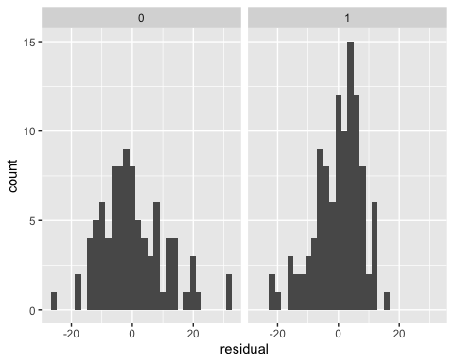 The histograms appear to be relatively bell-shaped and centered on 0.
get_regression_points(surveygender)%>%
ggplot(aes(Survey1, residual))+
geom_point()+
geom_hline(yintercept = 0, col = "blue", size = 1)+
facet_wrap(~Gender)
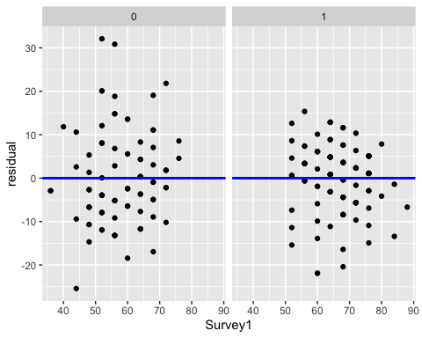 The spread of the residuals around y=0 does not appear obviously skewed.
summary(surveygender)
##
## Call:
## lm(formula = Survey2 ~ Survey1 + Gender, data = Handwriting)
##
## Residuals:
## Min 1Q Median 3Q Max
## -25.416 -5.651 0.318 5.096 32.078
##
## Coefficients:
## Estimate Std. Error t value Pr(>|t|)
## (Intercept) 43.63051 4.59354 9.498 < 2e-16 ***
## Survey1 0.31330 0.07759 4.038 7.79e-05 ***
## Gender1 3.46231 1.48740 2.328 0.021 *
## ---
## Signif. codes: 0 '***' 0.001 '**' 0.01 '*' 0.05 '.' 0.1 ' ' 1
##
## Residual standard error: 9.233 on 192 degrees of freedom
## (9 observations deleted due to missingness)
## Multiple R-squared: 0.1649, Adjusted R-squared: 0.1562
## F-statistic: 18.96 on 2 and 192 DF, p-value: 3.058e-08
Each of the p-values for the coefficients are below 0.05, and the model may meet the conditions of LINE, but the R-squared value is only 0.1649 so I would not call it a useful model.

Question 8
Create a regression model to determine if there is an interaction between guessing on the first survey and gender to predict the percentage correct on survey 2. Determine if the model is useful.
surveygender2 <- lm(Survey2 ~ Survey1 * Gender, data = Handwriting)
get_regression_table(surveygender2)
## # A tibble: 4 × 7
## term estimate std_error statistic p_value lower_ci upper_ci
## <chr> <dbl> <dbl> <dbl> <dbl> <dbl> <dbl>
## 1 intercept 37.5 6.35 5.90 0 24.9 50.0
## 2 Survey1 0.42 0.109 3.87 0 0.206 0.634
## 3 Gender: 1 17.0 9.75 1.74 0.083 -2.26 36.2
## 4 Survey1:Gender1 -0.217 0.155 -1.40 0.163 -0.522 0.088
get_regression_points(surveygender2)
## # A tibble: 195 × 6
## ID Survey2 Survey1 Gender Survey2_hat residual
## <int> <dbl> <dbl> <fct> <dbl> <dbl>
## 1 1 68 72 1 69.0 -1.04
## 2 2 68 56 0 61.0 7.02
## 3 3 48 68 1 68.2 -20.2
## 4 4 80 80 1 70.7 9.33
## 5 5 72 76 1 69.9 2.15
## 6 6 60 76 1 69.9 -9.85
## 7 7 60 60 0 62.7 -2.66
## 8 8 68 68 0 66.0 1.98
## 9 9 48 52 0 59.3 -11.3
## 10 10 72 64 1 67.4 4.58
## # ℹ 185 more rows
Handwriting%>%
filter(is.na(Gender)==FALSE)%>%
ggplot(aes(Survey1, Survey2, color=Gender))+
geom_point()+
geom_smooth(method= "lm", se=FALSE)+
facet_wrap(~Gender)
## `geom_smooth()` using formula = 'y ~ x'
## Warning: Removed 8 rows containing non-finite outside the scale range
## (`stat_smooth()`).
## Warning: Removed 8 rows containing missing values or values outside the scale range
## (`geom_point()`).
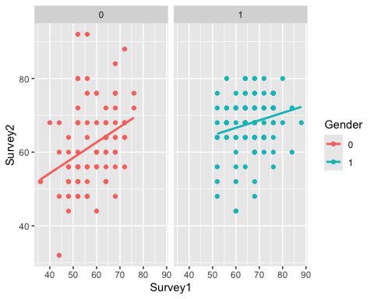
get_regression_points(surveygender2)%>%
ggplot(aes(residual))+
geom_histogram()+
facet_wrap(~Gender)
## `stat_bin()` using `bins = 30`. Pick better value with `binwidth`.
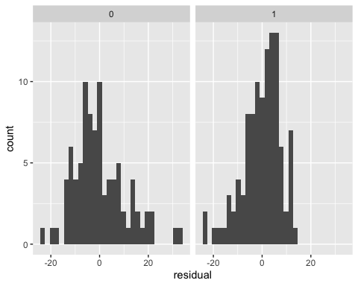
get_regression_points(surveygender2)%>%
ggplot(aes(Survey1, residual))+
geom_point()+
geom_hline(yintercept = 0, col = "blue", size = 1)+
facet_wrap(~Gender)
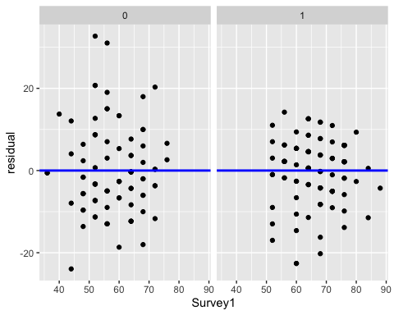
summary(surveygender2)
##
## Call:
## lm(formula = Survey2 ~ Survey1 * Gender, data = Handwriting)
##
## Residuals:
## Min 1Q Median 3Q Max
## -23.939 -5.042 -0.231 5.687 32.701
##
## Coefficients:
## Estimate Std. Error t value Pr(>|t|)
## (Intercept) 37.4606 6.3529 5.897 1.66e-08 ***
## Survey1 0.4200 0.1085 3.870 0.000149 ***
## Gender1 16.9725 9.7494 1.741 0.083316 .
## Survey1:Gender1 -0.2171 0.1548 -1.402 0.162516
## ---
## Signif. codes: 0 '***' 0.001 '**' 0.01 '*' 0.05 '.' 0.1 ' ' 1
##
## Residual standard error: 9.21 on 191 degrees of freedom
## (9 observations deleted due to missingness)
## Multiple R-squared: 0.1734, Adjusted R-squared: 0.1605
## F-statistic: 13.36 on 3 and 191 DF, p-value: 5.942e-08
Two of the coefficients have p-values above 0.05, and the R-squared value is only 0.1734 so I would not call it a useful model.

Question 9
a) Consider all of the models created in this assignment to explain the percentage guessed correctly on Survey 2 as explained by the percentage guessed correctly on Survey 1. Explain which model you would use.
surveygender2 has the highest r-squared value out of the models, and seems to meet the conditions of LINE, so surveygender2 is the model I would use.
b) Give the regression equation for the model you chose.
get_regression_table(surveygender2)
## # A tibble: 4 × 7
## term estimate std_error statistic p_value lower_ci upper_ci
## <chr> <dbl> <dbl> <dbl> <dbl> <dbl> <dbl>
## 1 intercept 37.5 6.35 5.90 0 24.9 50.0
## 2 Survey1 0.42 0.109 3.87 0 0.206 0.634
## 3 Gender: 1 17.0 9.75 1.74 0.083 -2.26 36.2
## 4 Survey1:Gender1 -0.217 0.155 -1.40 0.163 -0.522 0.088
$$\text{Predicted Survey2}=0.420*\text{Survey1}+16.973*1_{\text{Gender:1}}\left(\text{Gender}\right)−0.217*\text{Survey1}*1_{\text{Gender:1}}\left(\text{Gender}\right)+37.461$$
c) Generally, how much better does a woman than a man when they both guess 20% correct on survey 1?
0.420*20 + 16.973-0.217*20+37.461-(0.420*20+37.461)
## [1] 12.633
d) What is the predicted percentage correct on survey 2 when the people guessing is a woman and guessed 20% correct on Survey 1
0.420*20 + 16.973-0.217*20+37.461
## [1] 58.494
e) What is the predicted average percentage correct on survey 2 when the people guessing is a man and guessed 20% correct on Survey 1
0.420*20+37.461
## [1] 45.861

